**The AOC Individual & Couple Therapy Referral Form**

To Complete this referral form you MUST be 18+ years old.

Is This referral for an individual or a couple? Individual Couple

Are you filling out this referral form on behalf of someone? Yes No

If yes, do you have permission from all parties to fill out this form? Yes No

If yes, do all parties know they are being referred? Yes No

**If you are filling out this referral form on behalf of someone, please provide your details in section D on page 6.**

**Please list below the details of the person(s) being referred to receive therapy/counselling and please complete the appropriate section. If this referral is for an individual please complete section A and C. If this referral is for a couple, please complete section B and C.**

|  |  |  |  |
| --- | --- | --- | --- |
| **Section A. Individual:**  **Full Name:** | | | |
| **Male Female** | **Date of Birth:** | | **Age:** |
| **Adult Child** | | **School: (if appropriate)** | |

**Full Address:**

**Contact Number (Home): Mobile:**

**Preferred method of contact: Phone  Email  Post **

**Email Address:**

**Full Address:**

|  |  |  |
| --- | --- | --- |
| **Section B. Couple:**  **Full Name:** | | |
| **Male Female** | **Date of Birth:** | **Age:** |
| **Full Name:** | | |
| **Male Female** | **Date of Birth:** | **Age:** |

**Contact Numbers: (Home) Mobile:**

**Preferred method of contact: Phone  Email  Post **

**Email Addresses:**

**Preferred location/venue for appointments:**

**The AOC  Local School/Community Centre  Other **

**If Other, please specify:**

**Please note if you prefer to receive counselling/therapy support and you would like sessions to take place away from our office you are responsible for booking the required venue.**

**Section C:**

|  |  |  |  |  |
| --- | --- | --- | --- | --- |
| **Ethnicity:** | **African** | **Asian** | **Bangladeshi** | **White/Black Caribbean** |
| **White** | **Pakistani** | **Caribbean** | **Any other Asian** | **White/Asian** |
| **Irish** | **Jewish** | **Gypsy/Roma** | **Any Other Mixed** | **White/Black African** |
| **British** | **Chinese** | **Indian** | **Any Other Black** | **Other Ethnicity** |
| **Main Language Spoken by family:** | | | | |

**GP Name / Address:**

**If you have children do any of them currently supported by CAHMS:**

**Yes  No **

**If Yes, details:**

**Do you (or your partner) have any disabilities? Yes  No **

**If Yes, please give details:**

**Do you (or your partner) have any medical conditions? Yes  No **

**If Yes, please give details:**

**Are you (or your partner) currently on any medication? Yes  No **

**If Yes, details:**

**Are Social Care and Health involved with you? Yes  No **

**If Yes, details:**

**Are there or has there been any identified child protection issues related to you? Yes  No **

**If Yes, details?**

**Is the child on a Child Protection Plan? Yes  No **

**Has the case been referred to the police? Yes  No **

**Is the case open or closed after Court Case / Police Investigation:**

**Open  Closed **

**In the next box please provide details of why you are requesting individual or couple therapy/counselling. Please record past issues and problems as well as difficulties currently present.**

|  |
| --- |
| **Are you (or your partner) awaiting any court hearings, in prison, awaiting sentencing, on probation, or have any criminal convictions, please give brief details:** |

**Please tick the following boxes which apply to the client’s referral**

**Abuse  *Physical, emotional, psychological, sexual, neglect**

**Self-Harm  Attempted Suicide **

**Affected by Domestic Abuse  *Direct / Indirect**

**Separation Issues **

**Signed by:**

**Date:**

**Section D:**

**Referrer Details:**

*Relationship / Role to client: (eg: mother, son, doctor, teacher)*

*Referrer’s Full Name:*

*Agency / Organisation Address:*

*Phone Number: Mobile Number:*

*Email Address:*

*Date Referral Completed:*

*Referrer’s Signature:*

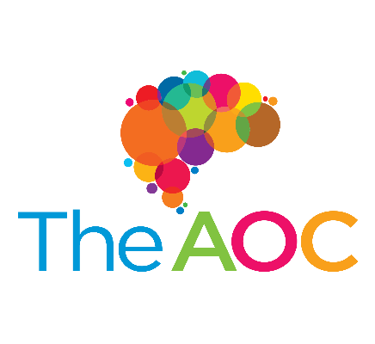

**Return Forms to: The Arts of Change / The AoC  
 27 Holloway Chambers,**

**Priory Street, Dudley,**

**West Midlands, DY1 1HA**

**Email: - support@theaoc.org.uk**